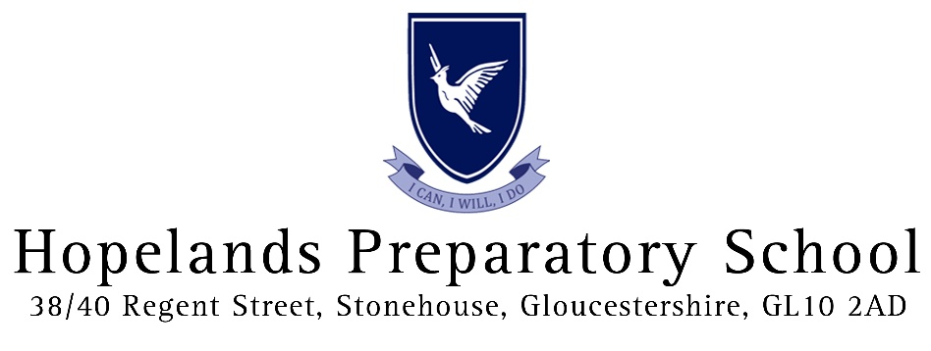
Health and Relationships Education Policy

Author: Mrs J White – PSHE Lead
Date: September 2020

Aims and Objectives of this policy
This policy is a working document which provides guidance and information on all aspects of PSHE (Personal, Social and Health Education) and RHE (Relationships & Health Education).
Relationships and Health education (RHE) is learning about the emotional, social and physical aspects of growing up, relationships and friendships. Personal, social and health education (PSHE) and relationship and health education (RHE) helps to give pupils the knowledge, skills and understanding they need to lead confident, healthy, independent lives and to become informed, active responsible citizens.
At Hopelands Preparatory School our PSHE/RHE curriculum will support the moral, cultural, mental and physical development of our pupils and prepare them for the opportunities, responsibilities and experiences in school and later in life. We believe that children should be given opportunities to engage with current issues so that they can make clear informed choices about new challenges and critical opportunities that will arise as they grow up and become responsible adults.
Our curriculum provides children with a wide range of learning opportunities and experiences across and beyond the classroom. Children are encouraged to contribute fully to the life of their school and community and children will learn to recognise their own worth, work well with others and become increasingly aware of the wider world. Children will have a clear understanding of their role as a citizen, not only in school but in the wider community.
Our PSHE/SRE Curriculum is designed to allow each child to:
- Recognise their own worth and develop their confidence, responsibility and ensure they make the most of their abilities
- Work well with others and prepare them to play an active role as citizens
- Develop positive, healthy relationships and respect for others
- Develop a resilient and positive, growth mindset
- Encourage them to develop good relationships and respect for the differences between people
- Know and understand what constitutes a healthy, safe lifestyle, both physically and mentally
- Develop online and offline safety awareness
- Be positive and active members of a democratic society
- Develop self-confidence and self-esteem, and make informed choices regarding personal and social situations

Implementation
Our scheme of work offers a broad, balanced, rich and vibrant curriculum that provides progressive pathways to achievement for all pupils and leads to open and communicative curriculum provision. The curriculum will be taught with the consideration of the needs of all pupils.
The PSHE curriculum has been designed to reflect a spiral curriculum that revisits and builds upon knowledge, creating a platform of continuity from one year to the next. The foundations will be put in place from the very first year in EYFS, and all subsequent year groups at Hopelands will now have RHE as part of PSHE.

In this academic year (2020-2021) we will deliver the titles of ‘Healthy Me’, ‘Relationships’ and ‘Changing Me’ and we will help pupils develop an understanding of the adult world by encouraging pupils to make informed decisions about their wellbeing, health and relationships.

RHE in PHSE lessons will differ from what pupils learn about puberty and reproduction as part of the KS1 and KS2 Science curriculum and it is important to note that it is not a statutory requirement to deliver sex education at primary phase, other than that which is required within National Curriculum of Science. Elements of related content, such as puberty, menstruation are a requirement of Health Education and will be taught as part of the Science curriculum at Hopelands.

DfE Guidance on these requirements can be viewed here:
https://assets.publishing.service.gov.uk/government/uploads/system/uploads/attachment_data/file/805781/Relationships_Education__Relationships_and_Sex_Education__RSE__and_Hea lth_Education.pdf

All the materials used with children as part of our Relationships education and non-statutory RSE are age appropriate. These have been developed to meet the needs of our pupils at Hopelands and parents are welcome to view any of the resources used as part of our PSHE/RHE curriculum approach. Please contact the PSHE coordinator at Hopelands to arrange this.
Our commitment
Our children are entitled to an empowering PSHE/RHE curriculum which enables them to:
- Stay safe and healthy, build self-esteem, resilience and empathy and raise aspirations.
- Embrace the Fundamental British Values of Democracy, the rule of law, individual liberty and mutual respect for and tolerance of those with different faiths and beliefs and for those without faith.
- Planned learning will progressively build on prior knowledge and understanding and support children in producing outcomes that are personal and relevant to each individual.
- We will ensure that the curriculum is regularly monitored and reviewed.
- Teaching, learning and pupil outcomes will be monitored, and feedback will be given around what is going well and what are the ways to grow.
- While personal views are respected, all RHE issues are taught without bias.
- Topics are presented using a variety of views and beliefs that are reflective of wider society.
- Pupils are able to explore and form their own opinions but are also taught to respect others that may have a different opinions and life experiences.
- Teachers will make use of ground rules within all RHE sessions to ensure that a safe learning environment is achieved to allow pupils to explore and discuss topics in an appropriate way, yet also be clear on expectations around inappropriate questions on unintended disclosures.

Parental right of withdrawal

Hopelands seeks to work in partnership with parents and carers to provide age-appropriate and effective Relationships & Health Education to children. Our programme of study aims to complement and support the role of parents as first teachers of their children. In accordance with Department for Education regulations, there is no parental right of withdrawal from Relationships Education, Health Education or sex education when delivered as part of the National Curriculum in Science.

Safeguarding

Teachers are aware that effective RHE which brings an understanding of what is and is not appropriate in relationships can lead to a disclosure of a child protection issue. If a child makes a disclosure, then the teacher will follow all safeguarding protocols.

If a member of the school team has any other concerns, they will bring the matter to the attention of the Designated Safeguarding Lead as a matter of urgency.

Inclusion

It is our intention that all children have the opportunity to experience a programme of Relationships and Health Education which is appropriate for their age, physical and cognitive development, with differentiated provision if required. We aim to ensure that our programme is accessible to all pupils, including any pupils with special educational needs or disabilities. In teaching Relationships and Health Education, we also understand the importance of equality and respect and the duties placed upon us by the Equality Act 2010.

Transparency

This policy is available to the school community via the school website.

This policy is available to the school community via the school website.

This policy was adopted at a meeting of | Hopelands Preparatory School
Held on
Date to be reviewed  Date of Last Review | September 2022  September 2020
Signed on behalf of the senior management team | 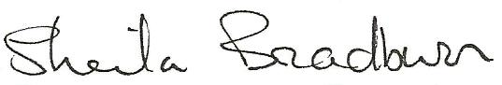
Name of signatory | Sheila Bradburn
Role of signatory | Head
Signed on behalf of the Governing Body | 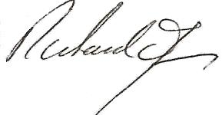
Name of signatory | Richard James
Role of signatory | Chair of Governors

