Parent/Staff Communications Policy

Scope of Policy
This policy applies to the school including the EYFS.

1. Permission for Absence

Parents wishing their child to be absent from school should write to the Head well in advance. The office will inform the form teacher if permission is granted. Any letters sent to the form teacher requesting absence should be redirected to the office.

2. Absence

Parents are encouraged to contact the school office at the beginning of every day of the child’s absence. This information will be passed on to the form teacher by the office.

If a pupil is absent because of illness, a phone call to the office or email to the office/form teacher or head will be expected.

3. Parents’ Evenings

These take place twice a year – Winter and Spring Terms. The meetings are designed for parents to visit school to discuss their child’s progress with their teacher. Appointments are made in advance; the times of the evenings are arranged by Form teachers and parents ad-hoc, generally between 8.00am to 6.00pm.

Any ‘problems’ relating to, or arising from, these evenings should be relayed back to the Head at the end of the evening or the next morning.
Hopelands operates an open-door policy so informal chats/talks with parents are encouraged/allowed at any time convenient for both parties.

4. Other Meetings/Discussions with Parents

File notes should be written whenever a member of staff has:

- requested an interview with a parent other than on the schedules Parents’ Evenings

- been approached by a parent who is concerned about any aspect of his/her child’s education, welfare etc.

- had communication with a parent over the telephone concerning the child.

Notes may be brief; only salient points need to be recorded. Notes should be shared with the Head who will then pass them on to the office for filing. File notes and letters received from parents should always be signed and dated (including year).

All letters sent home to parents on headed notepaper must be approved by the Head prior to distribution.

NB

If a member of staff considers the contents of a File Note to be of a ‘delicate’ or ‘sensitive’ nature it should be labelled ‘CONFIDENTIAL’.

5. Home School Link Book

Each child in Fox Cubs, Year 1 and 2 has a home-link book. This is a useful means of communication between staff and parents, particularly working parents. The book does not have to have something written in it each day but it should be checked on a daily basis.

6. Homework Diaries

Every child in Years 3 to 6 will have a Homework Diary which, for Years 3 and 4 must be signed by parents on a daily basis and for Years 5 and 6, once a week. These diaries are a useful tool to enable parents to see at a glance what work has been completed and communicate any issues with the work to the teacher.

7. E-mail and SMS text message

The school has an e-mail and SMS text message system to communicate with parents. This system is used to announce parents of issues around school including school closures and notices. Parents may contact members of staff directly by e-mail should they wish to communicate about their child(ren).

This policy was adopted at a meeting of | Hopelands Preparatory School
Held on | Nov 2020
Date to be reviewed | Nov 2022
Signed on behalf of the senior management team | 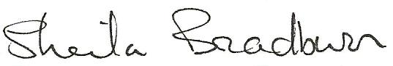
Name of signatory | Sheila Bradburn
Role of signatory | Head
Signed on behalf of the Governing Body | 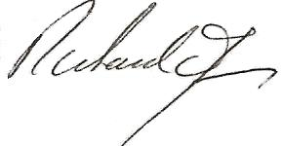
Name of signatory | Richard James
Role of signatory | Chair of Governors

