Safety, Health and Environment (SHE)
COVID-19 RISK ASSESSMENT PROCESS FOR HOPELANDS SCHOOL
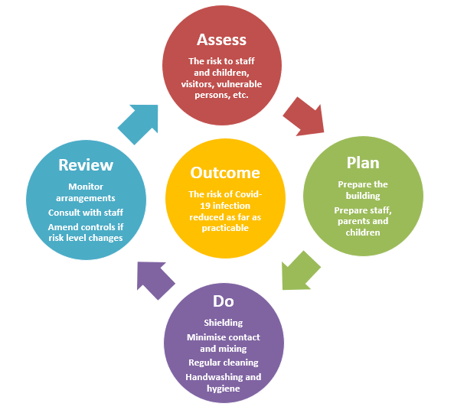
COVID-19 Risk Assessment for Hopelands School
Author: S Jones, May 2020
Agreed: S Bradburn, 19th May 2020
Shared with governors, staff and parents: 20th May 2020
Review date: 5th June 2020
ASSESS
Decide appropriate control measures for all school staff to implement under a ‘Plan’, ‘Do’, ‘Review’ cycle.
Who may be at risk: Employees, pupils, families (parents, carers and siblings), visitors, contractors, members of public.
Vulnerable groups – this risk assessment considers vulnerable groups which the NHS lists as ‘people at high risk (clinically extremely vulnerable)’; and ‘people at moderate risk (clinically vulnerable)’. An individual risk assessment may be appropriate for vulnerable employees and those who are very anxious about returning to their workplace.
PLAN |  | DO |  |  | REVIEW
Prepare Building | Prepare Employees and Parents and pupils | Control Access | Implementing Social Distancing | Implement Infection Control Measures | Communicate and Review Arrangements
- Ensure that all health and safety compliance checks have been undertaken before opening (e.g. fire alarm, emergency lighting, water hygiene, etc.).  - COVID-19 posters/ signage displayed (packs provided by GCC).  - Modify school reception/ early years entrance to maintain social distancing (floor markings).  - Consider one-way system if possible for circulation around the building.  - In areas where queues may form, put down floor markings to indicate distancing (stairs).  - Can separate doors be used for in and out of the building (to avoid crossing paths).  - Identify doors that can be propped open (to limit use of door handles and aid ventilation) taking account of fire safety and safeguarding. Seek advice from SHE if necessary.  - Identify rooms that can be accessed directly from outside (to avoid shared use of corridors).  - Organise classrooms for maintaining space between seats and desks. .  - Inspect classrooms and remove unnecessary items (Reception/ Class 2).  - Remove soft furnishings, soft toys and toys that are hard to clean.  - Put up laminated picture signs in toilets and classrooms in front of sinks showing handwashing.  - Make arrangements with cleaners for additional cleaning and agree additional hours to allow for this.  - A COVID-19 message to display on screens when locked. | - Involve employees in plans to return to school and listen to any suggestions on preventative measures that can be taken.  - Vulnerable employees and pupils (‘clinically vulnerable’ to coronavirus) identified and told not to attend school if shielding.  - Consider personal risk factors: age, obesity, pregnancy, existing health conditions and ethnicity.  - Where necessary individual risk assessments for employees and pupils at special risk (take account of medical advice).  - Review EHCPs where required.  - Regular communications that those who have coronavirus symptoms, or who have someone in their household who does, are not to attend school.  - Remote education is continuing as much as possible to limit numbers attending school.  - Assess how many employees are needed in school and identify those that can remain working from home.  - Employees shielding at home manage online work, whilst those in school only teach.  - Returning to school will be for groups on a priority basis (R, Class 2, Year 6)  - If shortage of teachers, allocate teaching assistants to lead a group, working under the direction of a teacher.  - Reviewing timetables to decide which lessons or activities will be delivered on what days.  - Smaller classes up to 15 pupils  - Identify and plan lessons that could take place outdoors.  - Use the timetable to reduce movement around the school or building.  - Planning break times (including lunch), so that all pupils are not moving around the school at the same time.  - Communicate to parents on the preventative measures being taken (e.g. post risk assessment on school website).  - Parents informed only one parent to accompany child to school.  - Staggered Pick up and Drop off at school gate only.  - Parents and pupils encouraged to walk or cycle where possible.  - Staggered drop-off and collection times planned and communicated to parents.  - Made clear to parents that they cannot gather at entrance gates or doors.  - Encourage parents to phone school and make telephone appointments if they wish to discuss their child (to avoid face to face meetings).  - Discourage parents and pupils from bringing in toys and other play items from home.  - Daily briefing to pupils on school rules and measures with reminders before leaving rooms.  - Review behaviour policies to consider how pupils not following distancing rules will be managed.  - Employees fully briefed about the plans and protective measures identified in the risk assessment.  - Regular staff briefings.  - Communication with contractors and suppliers that will need to prepare to support plans for opening (e.g. cleaning, catering, food supplies, hygiene suppliers).  - Communication with others (e.g. extended school provision, peripatetic music, regular visitors, etc.)  - Limit visitors by exception (e.g. for priority contractors, emergencies etc.).  - Keep parent appointments / external meetings on a ‘virtual platform.’ | - Entry points to school controlled through buzzer (including deliveries).  - Building access rules clearly communicated through signage on entrances.  - Parents’ drop-off and pick-up protocols to minimise contact.  - School start times staggered so class groups arrive at different times.  - Floor markings outside school to indicate distancing rules (if queuing during peak times).  - Hand sanitiser provided at all entrances.  - Visitors do not sign in with the same pen in reception.  - Staff on duty outside school to monitor protection measures. | - Safe distancing or 2 metres is a preventative measure that will be adopted so far as is reasonably practicable but it is acknowledged that this is not always possible in schools. However, all the measures in this assessment are aimed at reducing transmission risk.  - Reduced class sizes.  - Class groups kept together throughout the day and do not mix with other groups. Use of separate parts of the playground.  - The number of pupils in shared spaces (e.g. halls, dining areas and internal and external sports facilities) for lunch and exercise is limited to specific group(s).  - Assemblies not held.  - Packed lunch only with pupils eating outside (weather permitting).  - Limiting the number of pupils who use the toilet facilities at one time.  - Groups use the same classroom or area of a setting throughout the day.  - Seating plans to ensure pupils sit at the same desk.  - Desks should be spaced as far apart as possible.  - The same teacher(s) and other staff are assigned to each group and, as far as possible, these stay the same.  - Members of staff come to the classroom rather than groups of pupils circulate to different parts of the building/site.  - Subject teachers in smaller option subjects (e.g. practical subjects) collect small numbers coming out of main curriculum on a rota.  - Rooms accessed directly from outside where possible (R, Class 2).  - The occupancy of staff rooms and offices limited.  - Members of staff are on duty at breaks to ensure compliance with rules. | - Sufficient handwashing facilities are available.  - Frequent hand washing encouraged for adults and pupils (following guidance on hand cleaning).  - Hands cleaned on arrival at school, before and after eating, and after sneezing or coughing.  - Staff help is available for pupils who have trouble cleaning their hands independently.  - Adults and pupils are encouraged not to touch their mouth, eyes and nose.  - Adults and pupils encouraged to use a tissue or elbow to cough or sneeze and use bins for tissue waste (‘catch it, bin it, kill it’)  - Bins for tissues provided and are emptied throughout the day.  - Spaces well ventilated using natural ventilation (opening windows).  - Doors propped open, where safe to do so to limit use of door handles. Ensure closed when premises unoccupied.  - Sanitising spray and paper towels to be provided in classrooms for use by members of staff.  - Thorough cleaning of rooms at the end of the day.  - Shared materials and surfaces cleaned and disinfected frequently (e.g. toys, books, desks, chairs, doors, sinks, toilets, light switches, keyboards, bannisters, etc.).  - Toys and play equipment appropriately cleaned between groups of pupils using it, and not shared with multiple groups.  - Equipment used in practical lessons cleaned thoroughly between groups.  - Outdoor equipment appropriately cleaned between groups of pupils;  - Multiple groups do not use outdoor equipment simultaneously.  - Limit shared resources being taken home.  - Avoid sharing books and other materials.  - Procedures should someone become unwell whilst attending school.  - Staff providing close hands-on contact with pupils need to increase their level of self-protection, such as minimising close contact and having more frequent hand-washing and other hygiene measures, and regular cleaning of surfaces.  NOTE:  Wearing a face covering or face mask in schools or other education settings is not recommended by PHE.  The majority of employees in education settings will not require PPE beyond what they would normally need for their work (determined by existing risk assessment), even if they are not always able to maintain a distance of 2 metres from others. PPE is only needed in a very small number of cases including:  - if a pupil becomes unwell with symptoms of coronavirus while in their setting and needs direct personal care until they can return home.  However, PPE packs are being provided by GCC for all schools.  Employees providing first aid to pupils will not be expected to maintain 2m distance. The following measures will be adopted:  - washing hands or using hand sanitiser, before and after treating injured person;  - wear gloves or cover hands when dealing with open wounds;  - if CPR is required on an adult, attempt compression only CPR and early defibrillation until the ambulance arrives;  - if CPR is required on a child, use a resuscitation face shield if available to perform mouth-to-mouth ventilation in asphyxial arrest.  - dispose of all waste safely.  Should employees have close hands-on contact they should monitor themselves for symptoms of possible COVID-19 over the following 14 days. | - Consultation with employees and trades union Safety Reps on risk assessments.  - Risk assessment published on school intranet and website.  - Nominated employees tasked to monitoring protection measures.  - Employees encourage to report any non compliance.  - The effectiveness of prevention measures will be monitored by school leaders.  - This risk assessment will be reviewed if the risk level changes and/or in light of updated guidance.

