Rewards And Sanctions Policy

Scope of Policy
This policy applies to the school including the EYFS.

Green Card System

For work that is thorough, on time and completed to the highest ability of the individual pupil the teacher may award a House Point. In the case of excellent work, where the pupil has made extra effort, a pupil that has difficulty staying on task has done so for an entire lesson, or a pupil has excelled above and beyond the school code of conduct, a Green Card may be presented.

Teachers must set a very high standard for these cards in order to clarify their worth.

The card must be completed and passed to the pupil’s tutor who will maintain a record. At the end of term pupils who have received:

5 Green Cards = Bronze Badge
10 Green Cards = Silver Badge
15 Green Cards = Gold Badge

Red Card System

A warning is giving for any of the following:

Late/poor quality homework
Inappropriate talking
Lack of concentration
Other inappropriate behaviour

If, after two warnings are given, a third is required then this is accompanied by a red card.

The card must be completed by the teacher and a record kept in the register.

An immediate red card is given for bullying, swearing or extreme inappropriate behaviour.

Missed playtime can be given as a sanction to complete unfinished work, breech of uniform policy or as a punishment for ‘silly’ behaviour.

3 Red Cards or Missed Playtimes = One after school detention and a report card for one week.

Parents must be informed 24 hours prior to the detention which will be held from 3.45 pm to 4.15 pm with Mrs Bradburn. If a pupil receives 3 after school detentions in one term, then he or she will have to sit one full hour detention and a letter will be sent home to the parents.

A review is held termly of red cards distributed. Any pupil in year 6 receiving a red card cannot be Head boy or Head girl the term following the giving out of the red card.

Corporal punishment is not used or threatened.

This policy was adopted at a meeting of | Hopelands Preparatory School
Held on | November 2019
Date to be reviewed | November 2021
Signed on behalf of the senior management team | 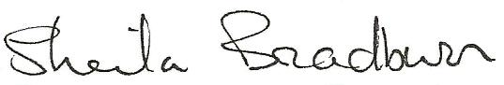
Name of signatory | Sheila Bradburn
Role of signatory | Head
Signed on behalf of the Governing Body | 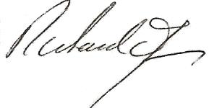
Name of signatory | Richard James
Role of signatory | Chair of Governors

