HOPELANDS PREPARATORY SCHOOL

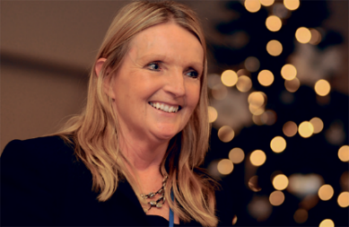
Sheila Bradburn – Headteacher and Head of Year 4
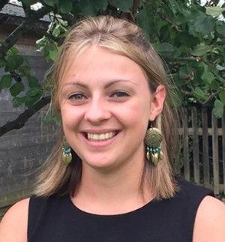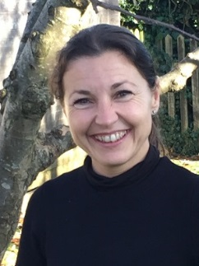
Ellie Porter Maria Boix Jo Preece Barbara Sands Hannah Gibbons
Head of Year 6 Head of Year 5 Head of Year 3 Head of Year 2 Head of Year 1
and Reception
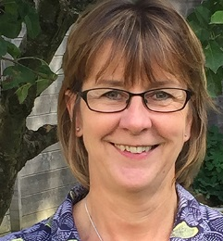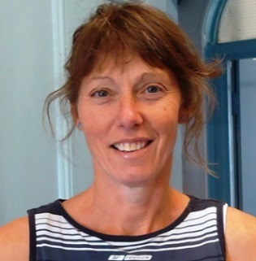
Lizzie O’Dell Jacky McQuillan Jane Barrett Steve Evans
Head of Music Head of PE Head of Art Head of Drama

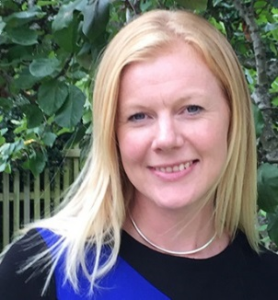
Suzanne Elmore Nicky Tomlinson
SENCo Dance Teacher
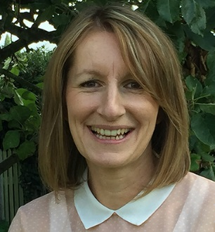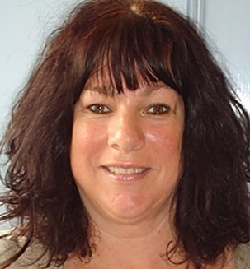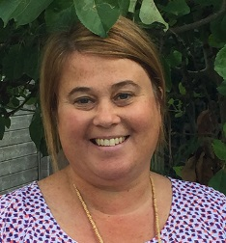
Claire Lord Julie Charles Lucy Stick
Teaching Assistant Teaching Assistant Teaching Assistant
SUPPORT STAFF
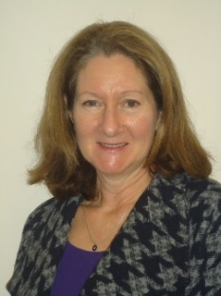
Sonja Jones Michele Eccles Harriet Bloomer
Bursar School Administrator Bookkeeper
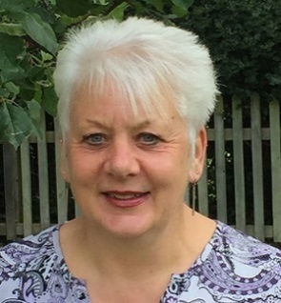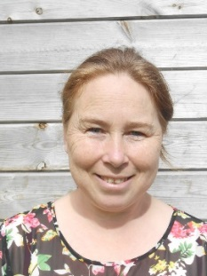
Pauline Seymour Donna Roberts Sarah Bloodworth
Lunchtime Supervisor Lunchtime Supervisor Lunchtime Supervisor

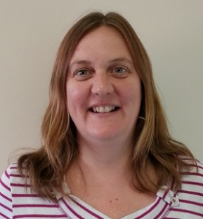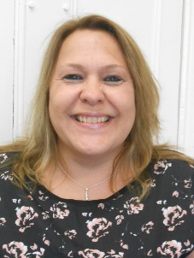
Charlie Coles Sara Brown
Morning and Afternoon Care Afternoon Care
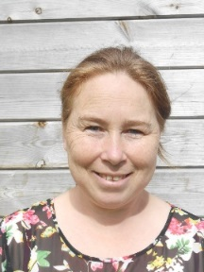
Roz Coombes Sarah Bloodworth Talia Messenger
Cleaning Staff Cleaning Staff Cleaning Staff
Roger Croft
Maintenance

