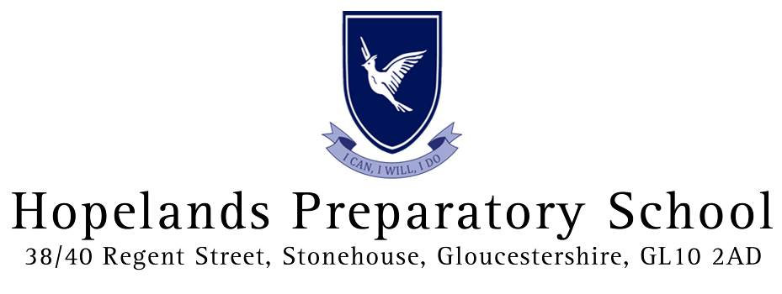
Relationships and Sex Policy

Relationships and Sex Education Policy
This policy covers our approach to the teaching of Relationships and Sex Education (RSE) at Hopelands School. We believe that a comprehensive programme of RSE should provide accurate information about the body, reproduction and sexual health. It should also give children essential skills for building positive, enjoyable, respectful and non-exploitative relationships and staying safe both on and offline.
This policy is written with due regard to the Secretary of State’s Sex and Relationship Education Guidance (DfE 2000). The Department of Health set out its ambition for all children and young people to receive high quality Relationships and Sex education in the Sexual Health Improvement Framework (2013), while the Department for Education’s paper The Importance of Teaching (2010) highlighted that ‘Children need high quality Relationships and Sex education so they can make wise and informed choices’. We are committed to monitoring and evaluating the effectiveness of this policy through pupil feedback; staff review and feedback, particularly at staff meetings; and parental feedback. This policy is available for all to view on the school’s website.
Aims and Objectives
In PSHE at Hopelands, we encourage the children to grow into confident and responsible individuals. We help them to understand the need for a safe and healthy lifestyle. We prepare them to be active citizens, to develop good relationships and to respect others. Pupils are taught:
- how to develop and maintain a variety of healthy relationships, within a range of social/cultural contexts
- how to recognise and manage emotions within a range of relationships
- how to recognise risky or negative relationships including all forms of bullying and abuse
- how to respond to risky or negative relationships and ask for help
- how to respect equality and diversity in relationships.
In Key Stage 1 we aim to lay the foundations of understanding about growth and change, and respect for one another. Pupils learn the names for the main parts of the body (including external genitalia) and the similarities and differences between boys and girls.
In Key Stage 2 pupils learn how their body will, and emotions may, change as they approach and move through puberty. They learn about human reproduction. Pupils also learn how to take care of their body, understanding that they have autonomy and the right to protect their body from inappropriate and unwanted contact. Good resources such as picture cards, games, puppets and 3D models, where they have been selected to meet particular needs, can enhance learning. Resources, especially those that are freely available on the internet, are checked to make sure they support inclusion, contain accurate information from authoritative medical sources, and clearly separate opinions, beliefs and facts. We assess pupils’ learning through group work discussion, debates and worksheets.
Partnership with Parents
We recognise the vital role played by parents in this aspect of their child’s education and a letter is always sent home to notify Year 6 parents prior to the ‘Growing Up’ lessons. Lesson plans are available for parents who wish to see them and a DVD is available for any families wishing to borrow it. Parents are invited to raise any queries or concerns, and may express a preference for their child not to participate in the lessons. Staff will ensure that any child who is withdrawn is protected from peer pressure.
Partnership with Pupils
We are mindful that pupils come to these lessons with different levels of prior knowledge. Teachers are sensitive to this and lessons are carefully planned and adapted to take this into consideration. We will identify the different starting points of pupils with a general pre-topic discussion and check-list. Careful consideration and respect will also be given to pupils’ different levels of maturity and personal circumstances, sexual orientation, gender identity, faith or culture, and those of their immediate family, which may or not be something they have yet considered or may be emerging. Therefore, RSE must be sensitive to the different needs of individual pupils and may need to evolve and adapt over time as the pupil population changes.
It is important that children feel able to ask any questions that they wish and that their questions are valued. An anonymous question box is set in the classroom, where pupils who are not comfortable raising questions in an open setting may ask questions to be responded to at a later date. Teachers answer questions on behalf of the school and should feel able to work with colleagues to construct an appropriate answer to any difficult questions. The question box is a good ‘holding place’ for such questions, while the teacher seeks guidance from the Leadership Team on an appropriate response.
Partnership with Staff
We believe that most of the RSE programme is best discussed openly with teachers who are known and trusted by the pupils. Teachers require sensitivity to the needs of the group, an ability to deal with questions openly and honestly and a readiness to refer to expert advice if necessary. Attending to relevant courses is a vital part of raising standards in RSE because training allows teachers to develop the confidence and skills needed to deliver effective and appropriate RSE.
Cross-curricular Education
Science teaches about the biological facts relating to human growth, puberty and reproduction. PSHE helps pupils to think about the different social contexts, influences and beliefs that affect personal behaviour. PSHE also develops a positive vocabulary and the strategies and skills children and young people need to stay healthy and safe. At Hopelands we also educate about online safety. It is vital to teach our children that the internet and social media are important resources for learning and information, and a great opportunity to build social networks, as well as teaching about the entailed risks and how to stay safe online. There will also be relevant learning in RE about the law and the views of religious and secular groups on different issues.
Rights as Individuals
There is likely to be debate on whether or not some relationship choices are acceptable. There is likely to be broad agreement that others are not acceptable, for example deliberately hurting others emotionally or physically. It is essential that lessons are sensitive to a range of views, but the school must ensure that pupils always have access to the learning they need to stay safe, healthy and understand their rights as individuals. This should include clear, impartial scientific information, as well as covering the law in relation to forced-marriage and female genital mutilation. Being open and honest about the words for genitalia will support girls at risk of female genital mutilation (FGM). The summer holiday between leaving primary and starting secondary school is a risk period for girls at risk of FGM so this knowledge must come in good time.
Anti-bullying
It is also crucial for lessons to help children to realise the nature and consequences of discrimination, teasing, bullying and aggressive behaviours (including cyber bullying and homophobic bullying), use of prejudice-based language and how to respond and ask for help.
Safeguarding
If we have any reason to believe a pupil is at risk, staff will follow the school’s safeguarding procedures and notify the Designated Safeguarding Lead.

This policy was adopted at a meeting of | Hopelands Preparatory School
Held on | November 2019
Date to be reviewed | November 2021
Signed on behalf of the senior management team | 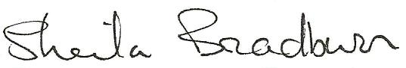
Name of signatory | Sheila Bradburn
Role of signatory | Head
Signed on behalf of the Governing Body
Name of signatory | Richard James
Role of signatory | Chair of Governors

