Attendance Policy

Aim: To Encourage All Children To Attend School Every Day And To Be On Time.

Scope of Policy
This policy applies to the school including the EYFS.

School begins at 8:45am. The Attendance Registers are at 8:45am each morning, closing at 9:05am and each afternoon at 1:15pm, closing at 1:20pm and sent to the office. Registers should be completed in black ink. If pupils convey the registers, any letters from parents must be securely held in the plastic wallet in the back of the register and not able to fall out or to be read by the pupil.

The registers are completed according to the County Guidelines as set out on the front page. Correcting fluid must not be used, but an explanation of any changes clearly visible.

Any child arriving late should report to the office. If a child is continuously late, the parents will be informed. The head monitors the arrival of the late attendances and will on occasion speak to the pupils, although often it is not the fault of the child.

If a child is not present for registration and parents have not informed the school, the school will make contact with the parents by 9.30am. In the event that a parent is not available, the emergency contact will be used and an email to the parent is sent. The school will continue throughout the school to contact the parents.

Any absence or lateness, which is causing concern to the teacher, will be investigated.

All absences are treated as unauthorised unless and until the school authorises the absence. If a parent informs the school that the child is ill or attending an acceptable appointment, the school will authorise the absence. Holidays can only be authorised by the head, at her discretion, and only up to 10 days per year. Following a request, an authorisation letter explaining the school’s concerns regarding absences due to holidays, will be sent to parents.

Any serious attendance concerns will be reported to the Educational Welfare Officer and Early Help will be contacted if necessary.

Please also refer to SEND Policy and Safeguarding Policy.

This policy was adopted at a meeting of | Hopelands Preparatory School
Held on | May 2018
Date to be reviewed | May 2020
Signed on behalf of the senior management team | 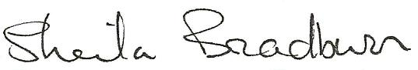
Name of signatory | Sheila Bradburn
Role of signatory | Head
Signed on behalf of the Governing Body | 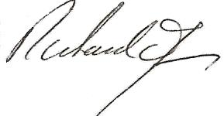
Name of signatory | Richard James
Role of signatory | Chair of Governors

