On Friday 25th November pupils from Years 2 and 6 went along to Meadow Lane play area in Stonehouse; at the personal invitation of the Mayor, Theresa Watt, to assist in a tree planting project.
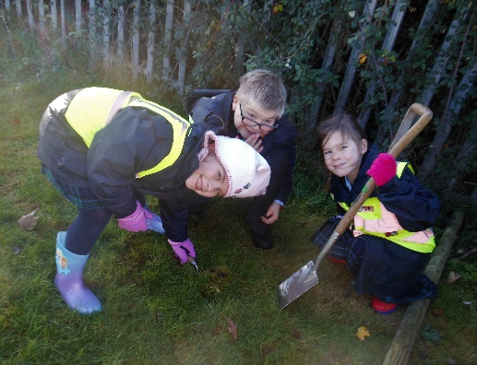
Stonehouse Town Council have been given a grant by the National Tree Council for six large trees, and also some small hedgerow trees, to be planted to add wildlife and landscape interest to the park as well as planting a new hedge alongside the railway to replace the screening that was cut down by Network Rail a couple of years ago.
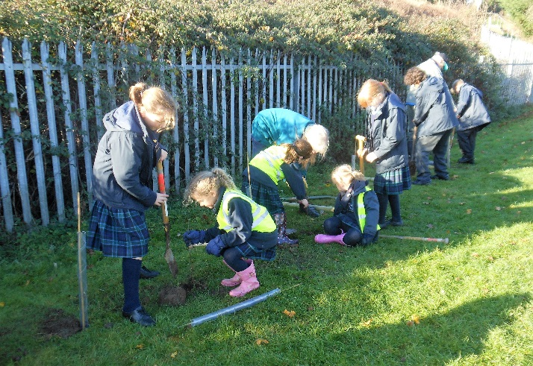
Mrs Sands, along with some very willing volunteers, took the children to Meadow Lane armed with some stout spades and wellies. There they heard a talk about why the council is doing the planting and wear also given a briefing on how to plant a tree safely.
Everyone had a super time and learned a lot about tree conservation and the need to preserve our wildlife and landscape heritage.
