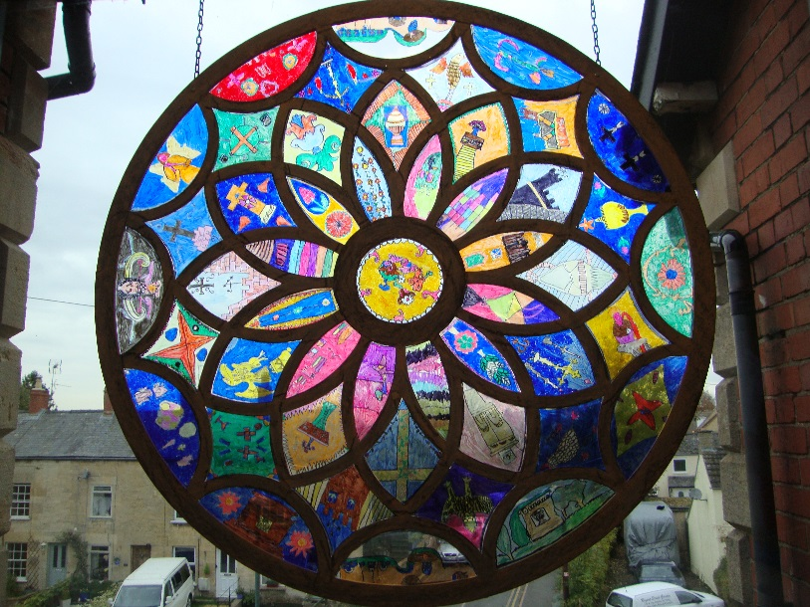
Hopelands Preparatory School has been brightened by a stunning, permanent display of ‘stained’ glass. The project was initiated by the Head of Art Jane Barrett. Pupils visited the local church of St Cyr's, Stonehouse, where sketches were made on site. In school these were developed by each child to create a design of their own which would fit their allocated aperture in one of the large church 'windows'. The frames were made of solid wood by Amos Joinery specifically to showcase to windows to full effect. Every child contributed and the finished results now hang in the main windows at both the front and back of the school. Not just parents and staff but also passers-by have been full of praise for their work and the children have been justifiably pleased with the result of their labours.
Thanks must also go to the Reverend Charles Minchin for his active support. The Reverend visited the school to share the results of this collaborative work and enjoyed spending some time spotting features from his church as portrayed in the children's art.
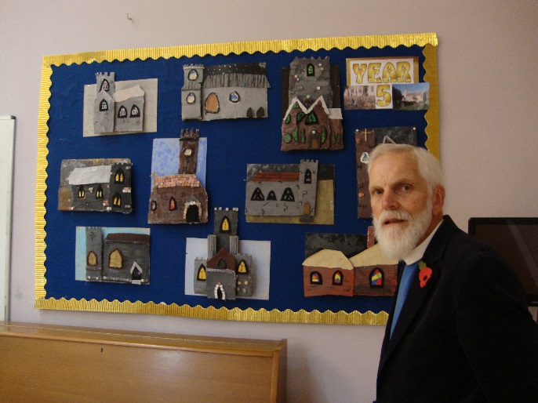
The church visit has also inspired further artwork which is also on display, including plaster 2D plaques and mixed media rose window designs.
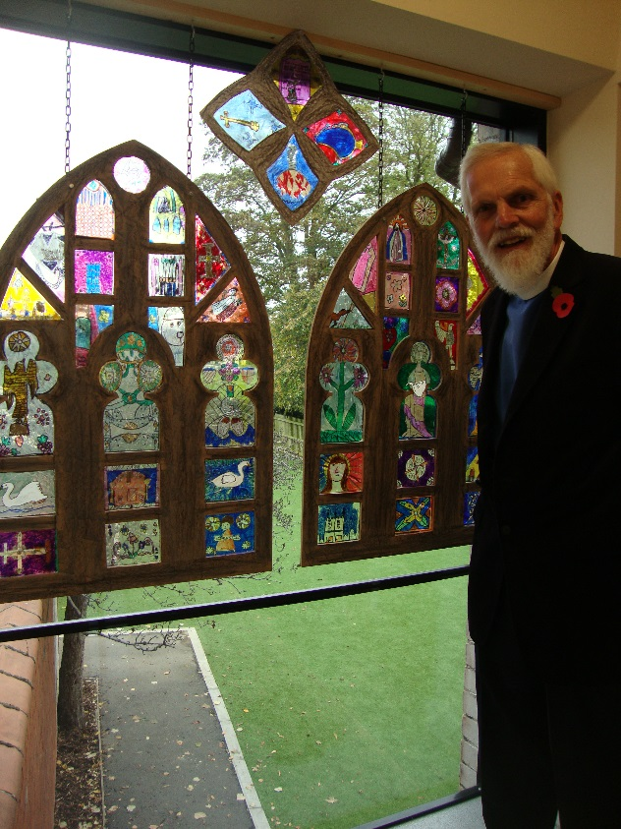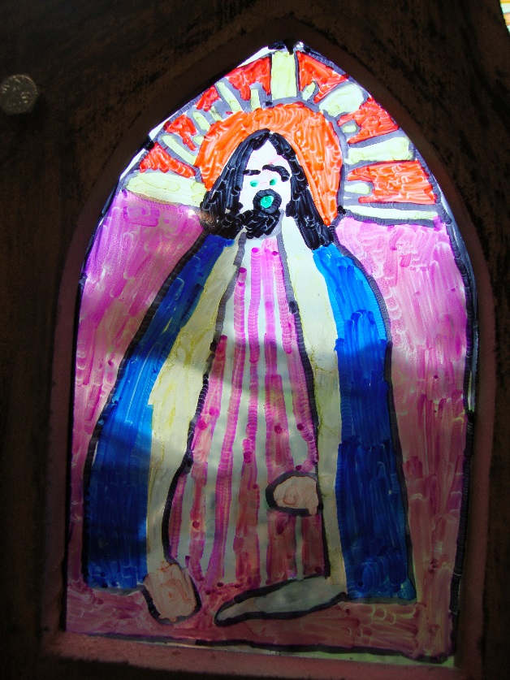
Says Mrs Barrett ‘It still astounds me how creative and gifted our pupils can be. I have been deeply touched by the care with which these windows have been designed and executed and by the obvious joy that shines from their work’.

