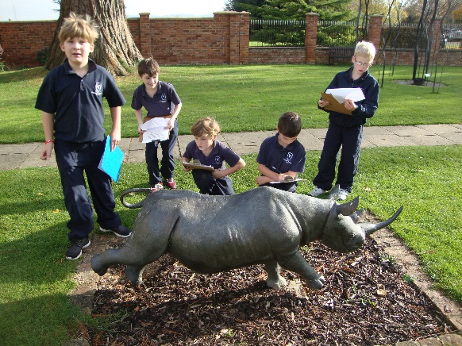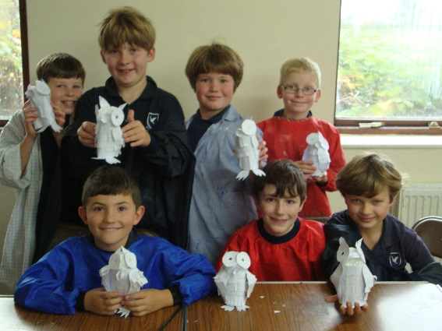

Pupils from Hopelands Preparatory School had a fun day out at the Nature in Art Exhibition at Twigworth, Gloucester recently. The children engaged in a number of art-based activities, toured the exhibits, chatted to the artists in residence and viewed the gardens. Pupils made 3-D paper owls and some exquisite glass butterflies.

