It is great to be back teaching once again, I’m now bionic (new hip)!
The children have had an exceptionally busy Autumn term with many tournaments taking place; for example: cross county, netball, football, & lacrosse.

Hockey: We enjoyed a wonderful time at The College, Cheltenham at a hockey skills afternoon played on astroturf for the first time. The Hopelands’ teams were playing against year 7/8 children and their ability matched that of their opponents.
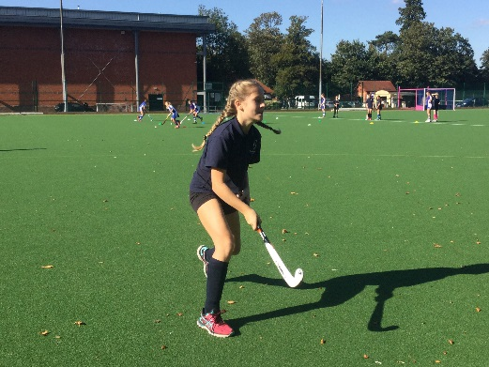

Cross Country: At present we are in the winning position, by a good number of points after 3 races, for the district trophy. And against both large and small schools! Just 3 more races to go!

Netball: During the first half of the season we have competed well enough in the district netball tournament to also be top of the leader board. Perhaps it was because of the team’s mascot?!
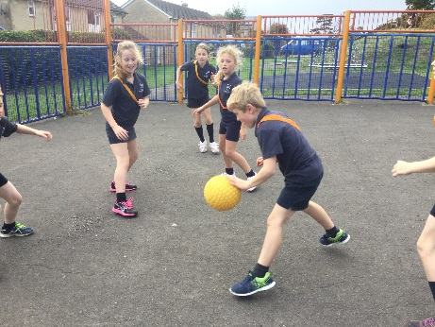
Football: The year 6 tournament was an exhilarating time with a variety of ages taking part for Hopelands. Plenty of skill was shown by several children especially Oliver Attwater-Staite and Daniel Vaughan.

All children in KS2 and 1 have had an exciting time both on and offsite as shown by the photographs:-
Tumbling and climbing at the playpark improved bat and racket skills. They have played equal opportunity bell football, leap frog in the autumn leaves and basketball. Perhaps we should also mention the dreaded words Bleep test and the plank!!
