Tuesday 4th October saw us participate in the first match of the district netball league. We won 3 matches and drew another thus earning ourselves a great many points. The second part of the tournament takes place in March, so watch this space.

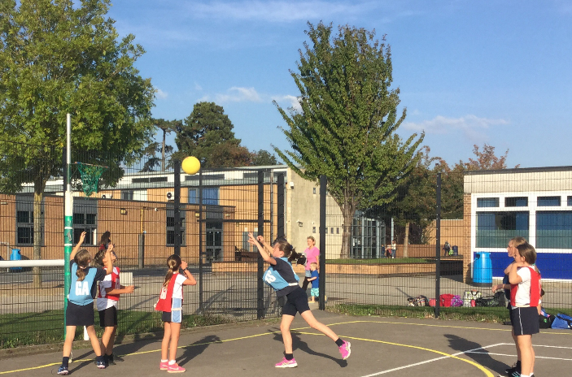

The first three cross-country races have been completed, with our girls coming top of both the small and large schools - winning all three races by a large margin. Over 120 children took part in the race and many of our girls came in the top 20. All the children that volunteered to represent the school have made everyone so proud. And congratulations should also go to the boys in year 4 and 5 for flying the flag for Hopelands.

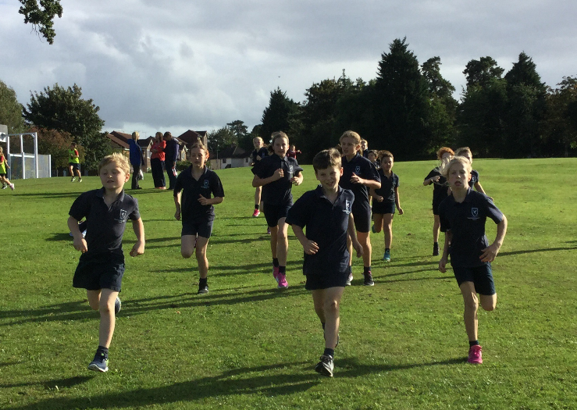

The hockey skills afternoon at The College in Cheltenham was arranged in order for the year 6 children to have an astroturf experience on a full pitch before moving to senior school. It was a very successful afternoon playing with The College’s Year 7 and 8 pupils. Hopelands displayed amazing skills and proved themselves to be the equal of their opponents.
